**Ideation Phase**

**Define the Problem Statements**

| Date | 24 June 2025 |
| --- | --- |
| Team ID | LTVIP2025TMID20422 |
| Project Name | LAPTOP REQUEST CATALOG ITEM |
| Maximum Marks | 2 Marks |

**Customer Problem Statement :**

Employees and IT teams face challenges when requesting laptops through the catalog system due to unclear specifications, lack of role-based recommendations, and inefficient approval processes. This results in delayed onboarding, mismatched devices, and increased administrative burden, ultimately hindering productivity and user satisfaction.

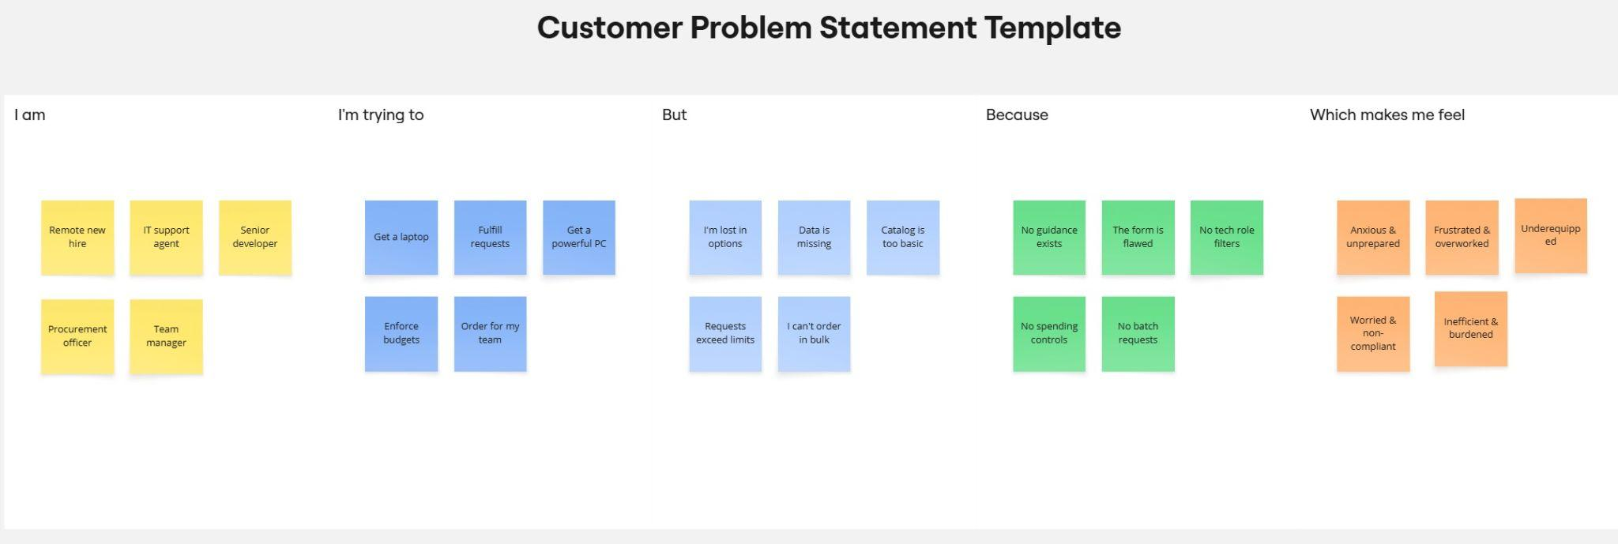

| **Problem Statement (PS)** | **I am (Customer)** | **I’m trying to** | **But** | **Because** | **Which makes me feel** |
| --- | --- | --- | --- | --- | --- |
| PS-1 | Remote new hire | Get a laptop | I'm lost in options | No guidance exists | Anxious & unprepared |
| PS-2 | IT support agent | Fulfill requests | Data is missing | The form is flawed | Frustrated & overworked |
| PS-3 | Senior developer | Get a powerful PC | Catalog is too basic | No tech role filters | Underequipped |
| PS-4 | Procurement officer | Enforce budgets | Requests exceed limits | No spending controls | Worried & non-compliant |
| PS-5 | Team manager | Order for my team | I can't order in bulk | No batch requests | Inefficient & Burdened |